***Experiment 01: Linux Commands***

1. Date



OPTIONS:

1.2) date +%m

1.3)date +%h

1.4)date +%d

1.5)date +%y

1.6)date +%H

1.7)date +%M



1.8)date +%S



1.9)date +%T



1.10)date +”%d %h %y”



2)cal

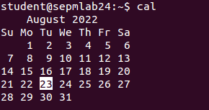

OPTIONS:

2.1)cal 04 1988

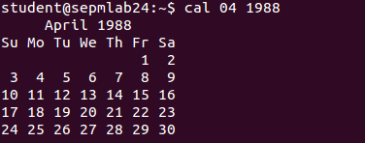

2.2)cal 2002

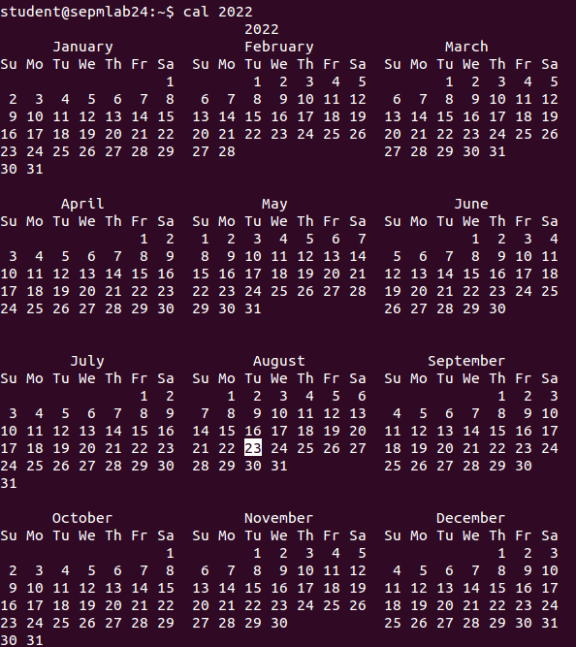

3)who am i



4) ps

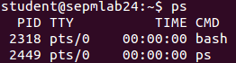

5) ls



OPTIONS:

5.1) ls -x



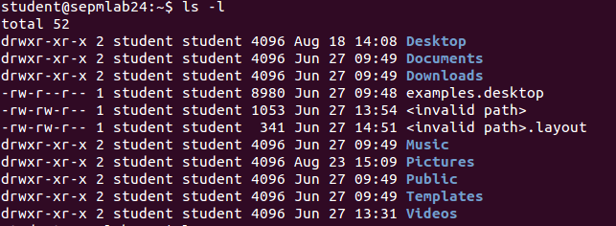5.2) ls -l

5.3)l s -f



5.4) ls -a



6)wc file_name

File:

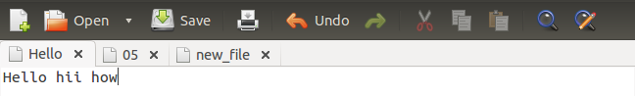 OPTIONS:

6.1)wc -l file_name



6.2)wc -w file_name



6.3)wc -c file_name



7)cat file_name



OPTIONS:

7.1)cat > new_file



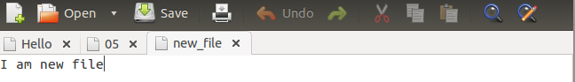

8) ls | wc -l

8.1) ls using metacharacters (* , > , | )

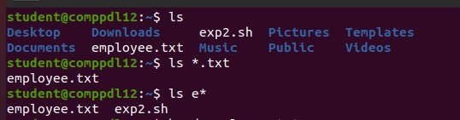

9)man command_name

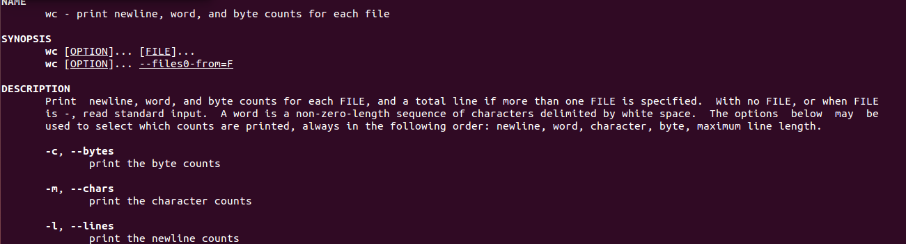

10)echo “string_to_be_printed”



11)ls first_char*



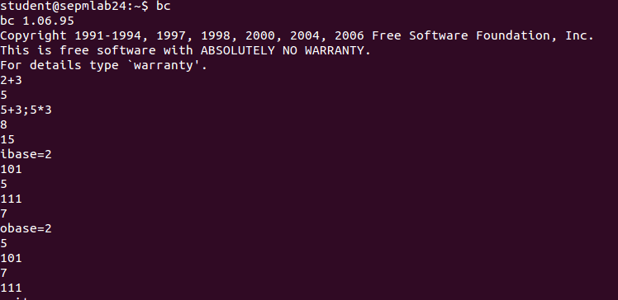12) bc

13)type wc



14)script

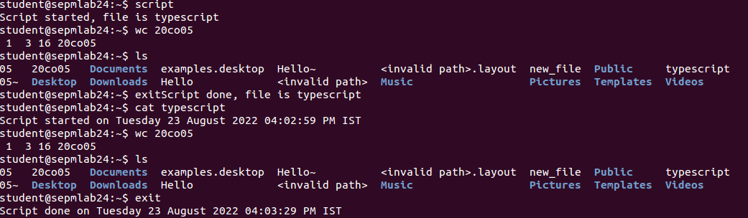

14.1)script -a

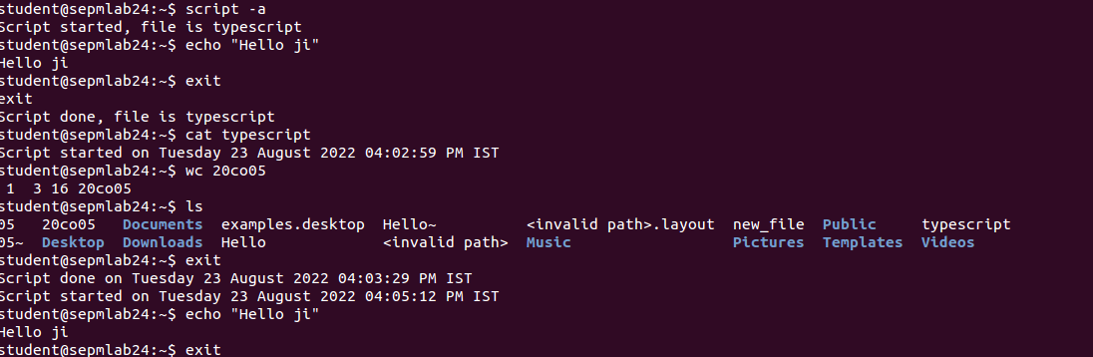

15)passwd



16)uname

OPTIONS:

16.1)uname -i



17)tty



18)pwd



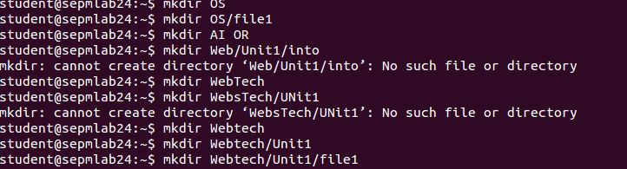19)mkdir

20)cd

21)cd ..

22)rmdir

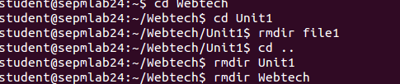

23)cp

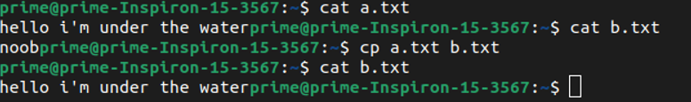

OPTIONS:

23.1) cp -i



24) rm

OPTIONS:

24.1) rm -i

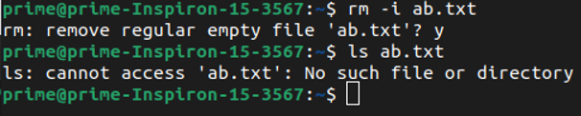

25)mv

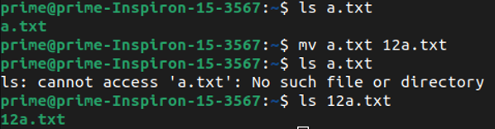

26) cmp



27) chmod [relative and absolute] -> At last

28)Shell variable declaration and display value

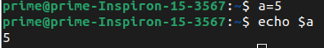

29) head

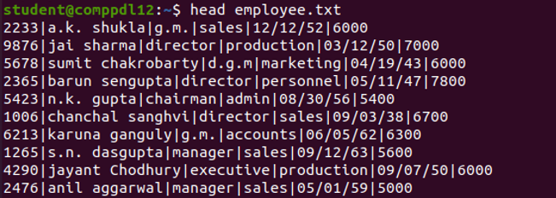

OPTIONS:

29.1) head -n

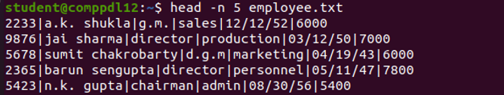

30) tail

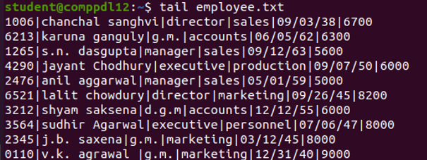

OPTIONS:

30.1) tail -n

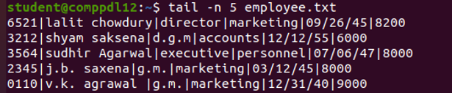

31) cut

OPTIONS:

31.1) cut -c

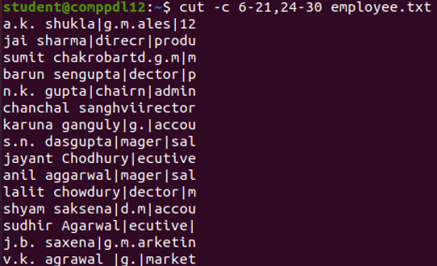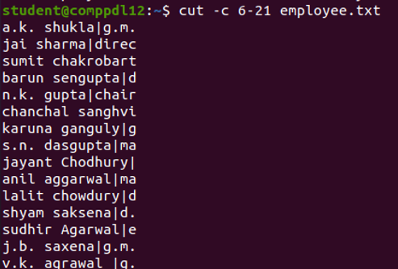

31.2) cut -f

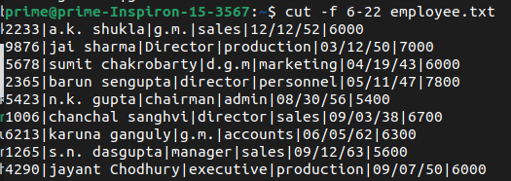

32) sort

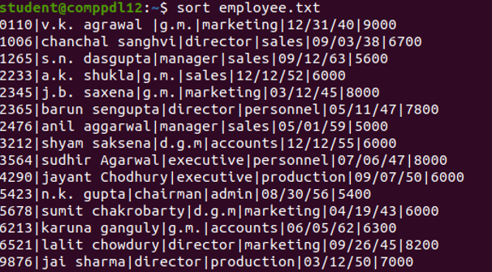

OPTIONS

32.1)sort -t

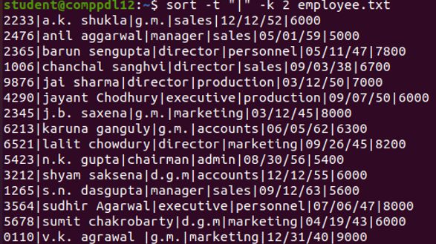32.2)sort -r

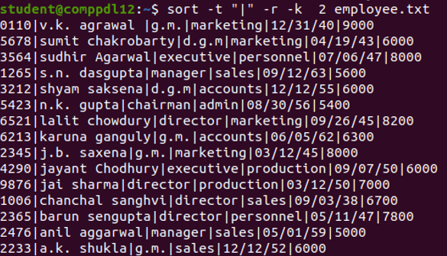

32.3) sort -k

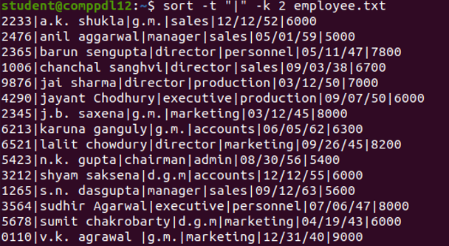

32.4) sort -r -k

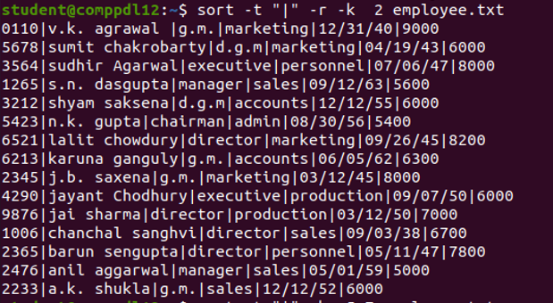

33) tr

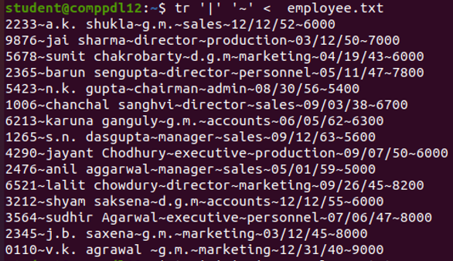

33.1) tr on head

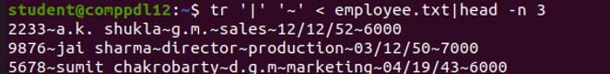

33.2) tr on tail

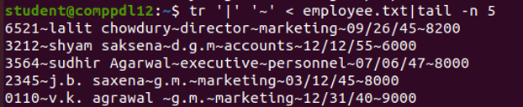

33.3) tr -d

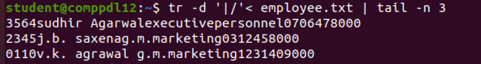

33.4) tr [changing cases]

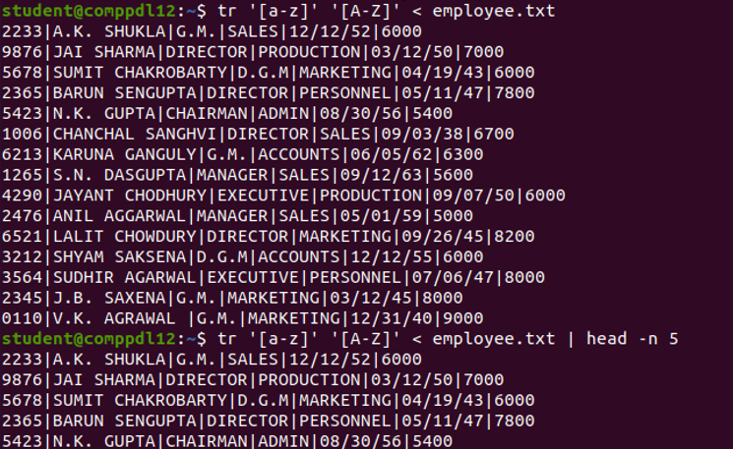

33.5) tr -s

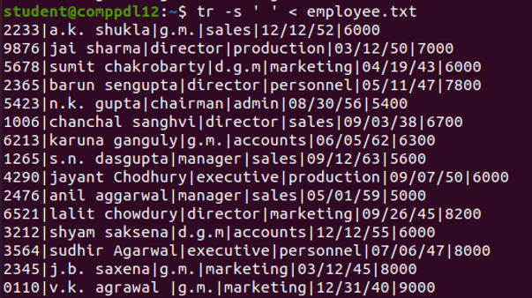

34) grep

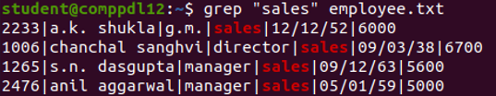

OPTIONS:

34.1) grep -i

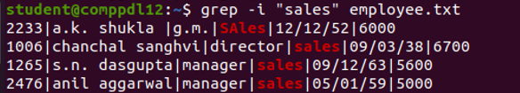

34.2) grep -v

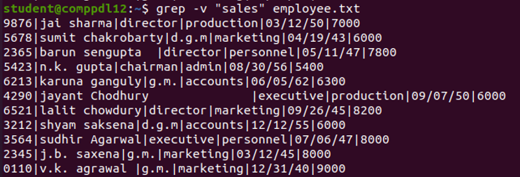

34.3) grep -c



34.4) grep -e



34.5) grep -l



34.6) grep [pattern]

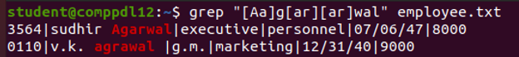

35) chmod

OPTIONS: {Relative)

Initial status:



35.1) Giving user execute right





35.2) Taking away execute write from user and group (ug)





35.3)Giving access to write to all three (ugo)

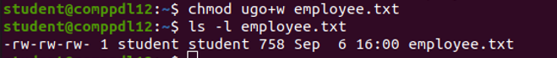

OPTIONS: (Absolute) [5 - r & x to user, 6 - r & w to group, 4 – r only for other)

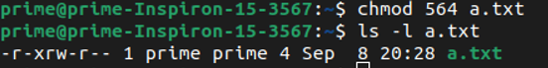

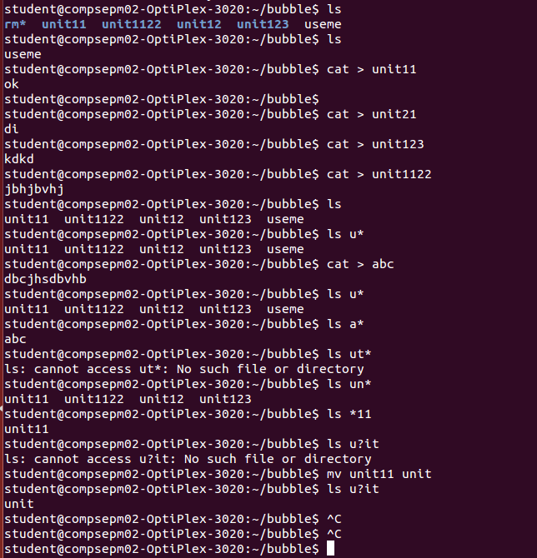36)wild cards [*, ?, [ijk], [!ijk], [x-z], [!x-z], . ]